Doc Writer: Rajanidhi Rajasekeran Doc Date: Jan 08, 2015.

Application or System Name
ENROLLMENT CENTER
General Overview
Ability to identify previous DPP customer at time of Move In and prompt Enrollment initiation.
An enhancement is needed in CRM to cover various DPP Enrollment Processes and sub processes in regards to how the enrollment and de-enrollment is initiated and completed in SAP. Alternative to this object is to, The CE user would have to remember themselves to initiate Enrollment request for the customer, manually investigate to identify if the account is considered eligible for Enrollment.
If implemented, CSRs will be able to easily identify customer program eligibility for the programs included in the Enrollment Center. Customer Program Enrollment and De-Enrollment will be initiated will be consistent for all programs included in the Enrollment Center.
Enrollment Center screen has four main component
- Participating program
- Available program
- Eligibility Messages
- Program History
Before displaying the enrollment center, Eligibility check is performed on the programs to check whether the programs are eligible or not.
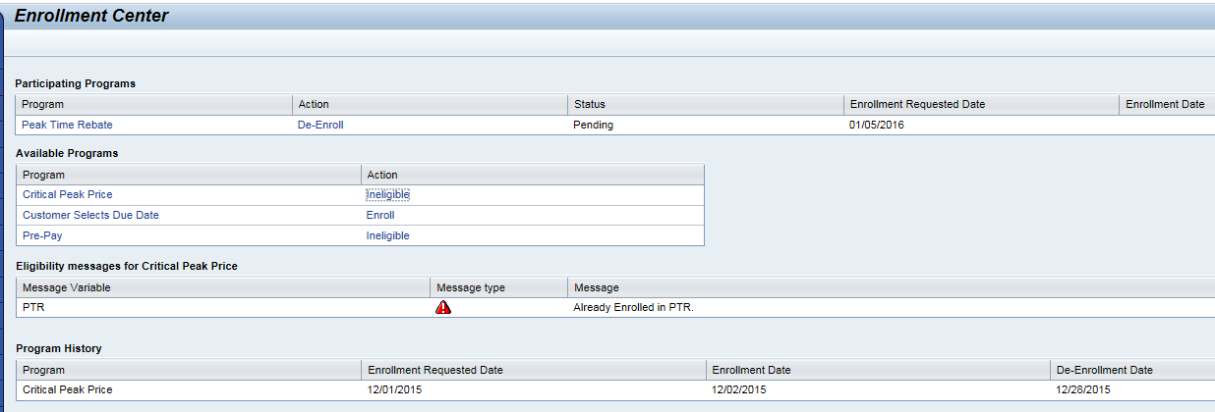

Technical Design:
Function Modules:
ENHANCEMENT DESIGN SPECIFICATIONS:
Enhancement Requirements
Number | Description of Requirement
1 | Creation of new Function Module to check the basic eligibility for Residential Customer, Electric Service and Over the air Meter Reading Capability.
2 | Creation of System Message in CRM prompting Customer Program Enrollment and Navigation to Enrollment Center.
3 | Creation of Enrollment Center component to show the CSR with the enrolled/eligible programs along with the eligibility messages and also the program history.

- Create Program Configuration tables in ECC to maintain program types and its attribute.
- ZTPGM_PROGID
- ZTPGM_PROGIDT
- ZTPGM_PROGLINK
- ZTPGM_EXCL
- ZTDM_DLA_EXCL
- Cluster view( Tcode - ZVCPGM_PROGRAMS ) is created for program types tables
- For Enrollment center go to the component work bench and the component Name ZPGMENROLL_CNTR go to Runtime repository.
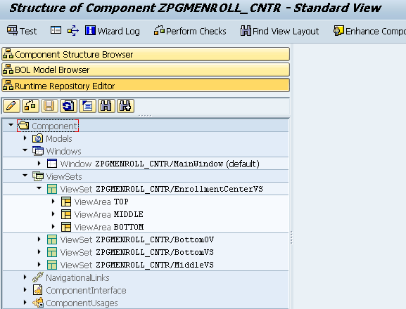
- Participating program is top, available program is in middle, bottom is divided into messages and program history.
- Go to component structure browser->Windows->ZPGMENROLL_CNTR/Mainwindow.
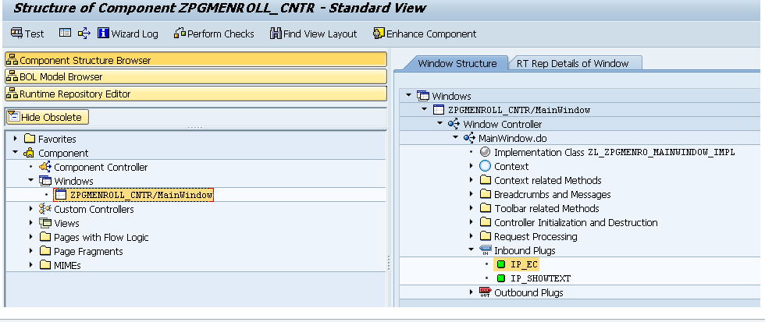
- Go to the Inbound Plugs IP_EC.
METHOD ip_ec.
DATA: lv_error TYPE boolean,
lv_abort TYPE boolean,
lv_msgno TYPE syst_msgno.
* Init
init( ).
* Perform Precheck
CALL METHOD precheck
IMPORTING
ev_error = lv_error
ev_message = lv_msgno.
* Perform Back to Ident
CALL METHOD nav_to_ident
EXPORTING
iv_error = lv_error.
* Throw Error Message
CALL METHOD show_message
EXPORTING
iv_error = lv_error
iv_message = lv_msgno.
* Load Program Enrollment
CALL METHOD load_pgmenrollment
EXPORTING
iv_error = lv_error.
ENDMETHOD.
- Here we will call the method PRECHECK it will checks for the confirmation from the customer and get the confirmed business agreement.
- Then perform back to identification here also we are calling the method NAV_TO_IDENT it will checks for error and get the navigation reference and navigate to the identification.
- Finally load the enrollment program it will execute the get enrollment methods and checks the eligibility.
- Here we are using a class ZCL_CRM_ISU_IL_PGENRL and another Genil object it is having two methods and three relations and the relations are program available, program enrolled and program history.
- Based on that search query enrollment object and gets an object it executes two methods gets the enrollment and eligibility checks and all the messages logic will be return based on error messages.

Go to the transaction code GENIL_MODEL_BROWSER.
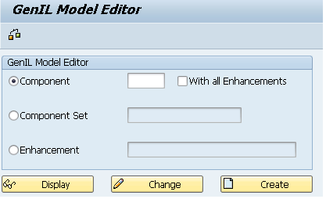
In the above Genil Model Editor and the Component is ZPGENL

Here we can see the Model objects-> Root Objects->Root Objects ProgramEnroll.

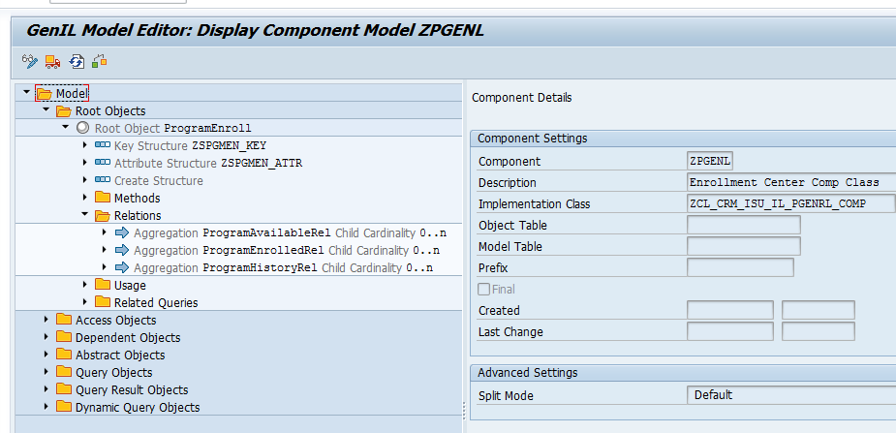

In this we can see key structure ZSPGMEN_KEY in this structure we can see enrollment business partner number, Enrollment contract account number, Enrollment program type and Enrollment requested date.
Also we can see the attribute structure ZSPGMEN_ATTR it Consist of all the program enrollment structure

Go to the transaction SE24 is a class builder ZCL_CRM_ISU_IL_PGENRL. Method IF_CRM_IU_IL_ABSTR_NROOT~EXECUTE has the Get Enrollment and Get Eligibility methods which is used to get the enrolled program and the eligible programs.

System Diagram
Technical Parts Inventory
-------Name------- | ----Description---- | -----Location----- | ----Environment---
ZPGMENROLL_CNTR | Component |  | C3D
ZCL_CRM_ISU_IL_PGENRL | Class |  | C3D
ZPGM_EC_ELIGIBILITYCHECK | Function Module |  | E2D
ZPGM_EC_GETENROLLMENT | Function Module |  | E2D

Dependent Parts Inventory
-------Name------- | ----Description--- | -----Location----- | ----Environment---
N/A | N/A | N/A | N/A

